Introduction to Python
- Python is a high-level, interpreted programming language.
- Easy to learn and use.
- Created by Guido van Rossum in 1991.
- Popular for web development, data science, AI, and automation.
Features of Python
- Simple and readable syntax.
- Open-source and free.
- Platform independent.
- Large standard library.
- Supports multiple programming paradigms
Applications of Python
- Web Development
- Artificial Intelligence & Machine Learning
- Data Analysis
- Automation & Scripting
- Game Development
- Desktop Applications
Advantages of Python
- Beginner-friendly language.
- Faster development process.
- Huge community support.
- Extensive libraries and frameworks.
- Easy integration with other technologies.
Built-in Data Types
- Text Type: str
- Numeric Types: int, float, complex
- Sequence Types: list, tuple, range
- Mapping Type: dict
- Set Types: set, frozenset
- Boolean Type: bool
- Binary Types: bytes, bytearray, memoryview
- None Type: NoneType

Setting the Data Type

Example | Data Type
x = "Hello World" | str
x = 20 | int
x = 20.5 | float
x = 1j | complex
x = ["apple", "banana", "cherry"] | list
x = ("apple", "banana", "cherry") | tuple
x = range(6) | range
x = {"name" : "John", "age" : 36} | dict
x = {"apple", "banana", "cherry"} | set
x = frozenset({"apple", "banana", "cherry"}) | frozenset
x = True | bool
x = b"Hello" | bytes
x = bytearray(5) | bytearray
x = memoryview(bytes(5)) | memoryview
x = None | NoneType

Setting the Specific Data Type
Example | Data Type
x = str("Hello World") | str
x = int(20) | int
x = float(20.5) | float
x = complex(1j) | complex
x = list(("apple", "banana", "cherry")) | list
x = tuple(("apple", "banana", "cherry")) | tuple
x = range(6) | range
x = dict(name="John", age=36) | dict
x = set(("apple", "banana", "cherry")) | set
x = frozenset(("apple", "banana", "cherry")) | frozenset
x = bool(5) | bool
x = bytes(5) | bytes
x = bytearray(5) | bytearray
x = memoryview(bytes(5)) | memoryview

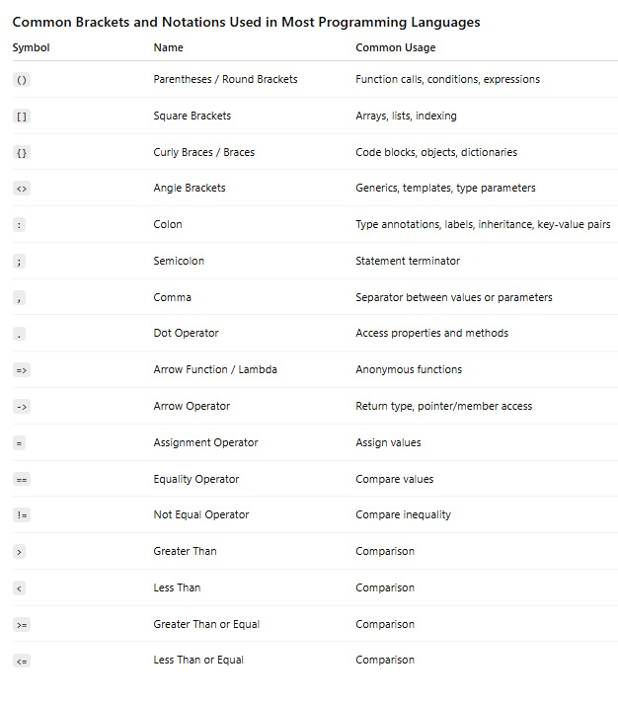

1. Text Type (str)

Used to store text or characters.
student_name = "Rahul"
course = "Python"
Real Example

A student's name in a training institute.
student_name = "Rahul"
print(student_name)
Output:
Rahul

2. Numeric Types
a) Integer (int)
Stores whole numbers.
age = 25
Real Example
number_of_students = 30
print(number_of_students)
Output:
30

b) Float (float)
Stores decimal numbers.
price = 199.99
Real Example
course_fee = 12500.50
print(course_fee)
Output:
12500.5

c) Complex (complex)
Used in scientific and mathematical calculations.
number = 4 + 3j
Real Example
electrical_signal = 5 + 2j
print(electrical_signal)
Output:
(5+2j)
3. Sequence Types
a) List (list)
Stores multiple items and can be changed.
students = ["Rahul", "Priya", "John"]
Real Example
courses = ["Python", "Java", "React"]
print(courses)
Output:
['Python', 'Java', 'React']

b) Tuple (tuple)
Stores multiple items but cannot be changed.
days = ("Monday", "Tuesday", "Wednesday")
Real Example
colors = ("Red", "Green", "Blue")
print(colors)
Output:
('Red', 'Green', 'Blue')

c) Range (range)
Generates a sequence of numbers.
numbers = range(1, 6)
Real Example
for i in range(1, 6):
print(i)
Output:
1
2
3
4
5

4. Mapping Type (dict)
Stores data in key-value pairs.
student = {
"name": "Rahul",
"age": 21
}
Real Example
employee = {
"id": 101,
"name": "Kumar",
"salary": 30000
}
print(employee["name"])
Output:
Kumar

5. Set Types
a) Set (set)
Stores unique values.
numbers = {10, 20, 30, 20}
Real Example
skills = {"Python", "Java", "Python"}
print(skills)
Output:
{'Python', 'Java'}
Duplicate values are removed automatically.

b) Frozen Set (frozenset)
A set that cannot be changed.
skills = frozenset(["Python", "Java"])
Real Example
courses = frozenset(["Python", "React"])
print(courses)
Output:
frozenset({'Python', 'React'})

6. Boolean Type (bool)
Stores only True or False.
Real Example
is_student = True
is_employee = False
print(is_student)
print(is_employee)
Output:
True
False

7. Binary Types
a) Bytes (bytes)
Stores binary data.
data = bytes([65, 66, 67])
print(data)
Output:
b'ABC'
Real Example
Used to store image, audio, or file data.

b) Bytearray (bytearray)
Similar to bytes but can be modified.
data = bytearray([65, 66, 67])
data[0] = 68
print(data)
Output:
bytearray(b'DBC')

c) Memoryview (memoryview)
Accesses binary data without copying it.
data = bytes([65, 66, 67])
view = memoryview(data)
print(view[0])
Output:
65

8. None Type (NoneType)
Represents no value or empty value.
Real Example
result = None
print(result)
Output:
None
Practical Example
student_name = None
if student_name is None:
print("Student name not entered")
Output:
Student name not entered

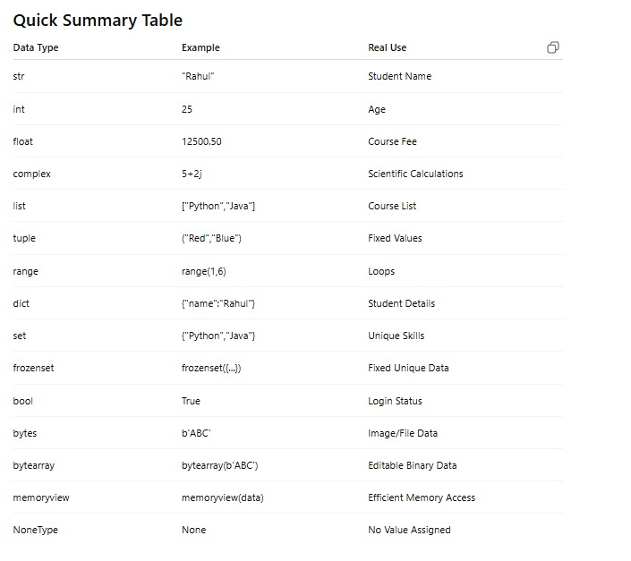
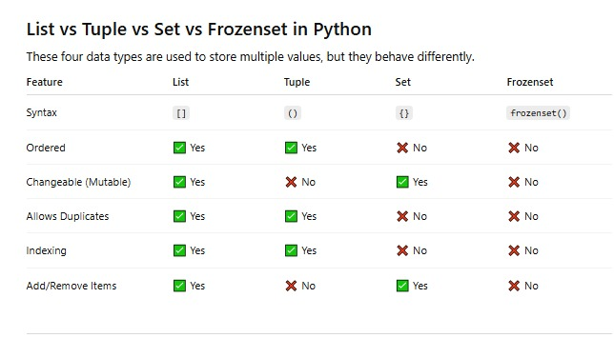

1. List (list)

A list is used when data can change.

Real Example: Student Names
students = ["Rahul", "Priya", "John"]

students.append("Kumar")

print(students)
Output
['Rahul', 'Priya', 'John', 'Kumar']

✅ Allows duplicates

students = ["Rahul", "Rahul", "John"]

✅ Supports indexing

print(students[0])

Output:

Rahul

2. Tuple (tuple)

A tuple is used when data should not change.
Real Example: Days of Weekend
weekend = ("Saturday", "Sunday")

print(weekend)
Output
('Saturday', 'Sunday')

❌ Cannot modify

weekend[0] = "Monday"

Output:

TypeError

✅ Useful for fixed data such as:

Coordinates
RGB Colors
Days of week
location = (12.97, 80.24)

3. Set (set)

A set stores unique values only.

Real Example: Student Skills
skills = {"Python", "Java", "Python"}

print(skills)
Output
{'Python', 'Java'}

Notice that duplicate "Python" is removed.

Adding New Value
skills.add("React")

print(skills)
Output
{'Python', 'Java', 'React'}

❌ No indexing

print(skills[0])

Output:

TypeError
4. Frozenset (frozenset)

A frozenset is an immutable set.

Real Example
courses = frozenset(["Python", "Java", "React"])

print(courses)
Output
frozenset({'Python', 'Java', 'React'})

❌ Cannot add items

courses.add("Angular")

Output:

AttributeError

Used when you need unique values that should never change.

Interview Example

Imagine a Training Institute:

List

Students joining daily.

students = ["Rahul", "Priya"]
students.append("John")
Tuple

Institute timings never change.

timing = ("9 AM", "6 PM")
Set

Unique technologies taught.

technologies = {"Python", "React", "Python"}

Result:

{'Python', 'React'}
Frozenset

Mandatory company policies.

policies = frozenset([
"ID Card Required",
"No Mobile During Exam"
])

Nobody can modify them accidentally.

Memory Trick
List → 📋 Can change, allows duplicates.
Tuple → 🔒 Cannot change, allows duplicates.
Set → 🎯 Unique values, can change.
Frozenset → ❄️ Unique values, cannot change.
Quick Code
my_list = [10, 20, 20]
my_tuple = (10, 20, 20)
my_set = {10, 20, 20}
my_frozenset = frozenset([10, 20, 20])

print(my_list)
print(my_tuple)
print(my_set)
print(my_frozenset)
Output
[10, 20, 20]
(10, 20, 20)
{10, 20}
frozenset({10, 20})

Python Operators
Operators are used to perform operations on variables and values.
Arithmetic Operators
Arithmetic operators are used with numeric values to perform common mathematical operations:
Operator | Name | Example
+ | Addition | x + y
- | Subtraction | x - y
* | Multiplication | x * y
/ | Division | x / y
% | Modulus | x % y
** | Exponentiation | x ** y
// | Floor division | x // y

Assignment Operators
Assignment operators are used to assign values to variables:
Operator | Example | Same As
= | x = 5 | x = 5
+= | x += 3 | x = x + 3
-= | x -= 3 | x = x - 3
*= | x *= 3 | x = x * 3
/= | x /= 3 | x = x / 3
%= | x %= 3 | x = x % 3
//= | x //= 3 | x = x // 3
**= | x **= 3 | x = x ** 3
&= | x &= 3 | x = x & 3
|= | x |= 3 | x = x | 3
^= | x ^= 3 | x = x ^ 3
>>= | x >>= 3 | x = x >> 3
<<= | x <<= 3 | x = x << 3
:= | print(x := 3) | x = 3  print(x)

The Ternary Operator
The ternary operator allows you to assign one value if a condition is true, and another if it is false:
Example
Assign a value to x:
Assign the value "WEEKEND!" if the number is higher than 5, otherwise "Workday":
num = 6
x = "WEEKEND!" if num > 5 else "Workday"
print(x)
Instead of Elif:
The ternary operator can be used instead of elif in longer if statements:
Example
Assign:
- "Fri" if num is 5
- "Sat" if num is 6
- "Sun" if num is 7
- otherwise assign "weekday":
num = 6
x = "Fri" if num == 5 else "Sat" if num == 6 else "Sun" if num == 7 else "weekday"
print(x)

Comparison Operators
Comparison operators are used to compare two values:
Operator | Name | Example
== | Equal | x == y
!= | Not equal | x != y
> | Greater than | x > y
< | Less than | x < y
>= | Greater than or equal to | x >= y
<= | Less than or equal to | x <= y

Logical Operators
Logical operators are used to combine conditional statements:
Operator | Description | Example
and | Returns True if both statements are true | x < 5 and x < 10
or | Returns True if one of the statements is true | x < 5 or x < 4
not | Reverse the result, returns False if the result is true | not(x < 5 and x < 10)

# Get input from the user
num1 = int(input("Enter first number: "))
num2 = int(input("Enter second number: "))

# Compare the numbers
if num1 > num2:
print("Greatest number is:", num1)
else:
print("Greatest number is:", num2)

# Get input from the user
num1 = int(input("Enter first number: "))
num2 = int(input("Enter second number: "))
num3 = int(input("Enter third number: "))

# Compare the numbers
if num1 >= num2 and num1 >= num3:
print("Greatest number is:", num1)
elif num2 >= num1 and num2 >= num3:
print("Greatest number is:", num2)
else:
print("Greatest number is:", num3)

num1 = int(input("Enter first number: "))
num2 = int(input("Enter second number: "))
num3 = int(input("Enter third number: "))

print("Greatest number is:", max(num1, num2, num3))
numbers = [50, 20, 80, 10, 30]

numbers.sort()

print(numbers)

a = 10
b = 25

print(min(a, b))

1. Simple if

Checks a condition and executes code only if it is True.

age = 20

if age >= 18:
print("Eligible to Vote")

Output:

Eligible to Vote
2. if-else

Executes one block if the condition is True and another if it is False.

number = 10

if number % 2 == 0:
print("Even Number")
else:
print("Odd Number")

Output:

Even Number
3. if-elif-else (Else If)

Used when there are multiple conditions.

marks = 75

if marks >= 90:
print("Grade A")
elif marks >= 80:
print("Grade B")
elif marks >= 70:
print("Grade C")
else:
print("Grade D")

Output:

Grade C
4. Find Greatest of Three Numbers
a = 20
b = 50
c = 30

if a > b and a > c:
print("A is Greatest")
elif b > c:
print("B is Greatest")
else:
print("C is Greatest")

Output:

B is Greatest
5. Check Positive, Negative, or Zero
num = -5

if num > 0:
print("Positive")
elif num < 0:
print("Negative")
else:
print("Zero")

Output:

Negative
6. Student Result System
marks = int(input("Enter Marks: "))

if marks >= 90:
print("Excellent")
elif marks >= 75:
print("Very Good")
elif marks >= 50:
print("Pass")
else:
print("Fail")
7. Nested If

An if inside another if.

age = 22
citizen = True

if age >= 18:
if citizen:
print("Eligible to Vote")
else:
print("Not a Citizen")
else:
print("Under Age")

Output:

Eligible to Vote
8. Login Validation Example
username = input("Username: ")
password = input("Password: ")

if username == "admin":
if password == "1234":
print("Login Successful")
else:
print("Invalid Password")
else:
print("Invalid Username")

1. for Loop

A for loop is used when you know how many times you want to repeat a task.

Syntax
for variable in sequence:
statements
Example 1: Print 1 - 5
for i in range(1, 6):
print(i)

Example 2: Print Student Names
students = ["Ram", "Sita", "John"]
for name in students:
print(name)

Example 3: Print Table of 5
Print Table of 5
for i in range(1, 11):
print("5 x", i, "=", 5 * i)

2. while Loop

A while loop executes as long as a condition is True.

Syntax
while condition:
statements
Example 1: Print Numbers 1 to 5
i = 1

while i <= 5:
print(i)
i += 1

Output

1
2
3
4
5
Example 2: Sum of First 5 Numbers
i = 1
total = 0

while i <= 5:
total += i
i += 1

print("Sum =", total)

Output

Sum = 15

Example 1: User enters table number and range
num = int(input("Enter the table number: "))
rng = int(input("Enter the range: "))

for i in range(1, rng + 1):
print(num, "x", i, "=", num * i)

Example 2: Using f-string (Professional Way)
num = int(input("Enter the table number: "))
rng = int(input("Enter the range: "))

for i in range(1, rng + 1):
print(f"{num} x {i} = {num * i}")

Example 3: Tables from Start Range to End Range
num = int(input("Enter the table number: "))
start = int(input("Enter the start range: "))
end = int(input("Enter the end range: "))

for i in range(start, end + 1):
print(f"{num} x {i} = {num * i}")

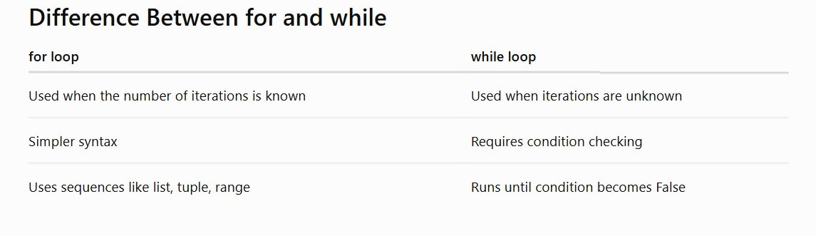
Python Collections (Arrays)
There are four collection data types in the Python programming language:

List is a collection which is ordered and changeable. Allows duplicate members.
Tuple is a collection which is ordered and unchangeable. Allows duplicate members.
Set is a collection which is unordered, unchangeable*, and unindexed. No duplicate members.
Dictionary is a collection which is ordered** and changeable. No duplicate members.

Python Logical Operators
Logical operators are used to combine conditional statements. Python has three logical operators:

and - Returns True if both statements are true
or - Returns True if one of the statements is true
not - Reverses the result, returns False if the result is true

1. Employee Bonus Calculation
salary = float(input("Enter Salary: "))

if salary >= 100000:
bonus = salary * 0.20
elif salary >= 50000:
bonus = salary * 0.10
elif salary >= 30000:
bonus = salary * 0.05
else:
bonus = 0

print("Bonus:", bonus)

Output

Enter Salary: 60000
Bonus: 6000.0
2. Income Tax Slab
income = float(input("Enter Annual Income: "))

if income <= 300000:
tax = 0
elif income <= 600000:
tax = income * 0.05
elif income <= 1000000:
tax = income * 0.10
else:
tax = income * 0.20

print("Tax Amount:", tax)
3. Student Grade System
marks = int(input("Enter Marks: "))

if marks >= 90:
grade = "A+"
elif marks >= 80:
grade = "A"
elif marks >= 70:
grade = "B"
elif marks >= 60:
grade = "C"
else:
grade = "Fail"

print("Grade:", grade)
4. Loan Eligibility Check
age = int(input("Enter Age: "))
salary = int(input("Enter Monthly Salary: "))

if age >= 21 and salary >= 50000:
print("Eligible for Premium Loan")
elif age >= 21 and salary >= 25000:
print("Eligible for Basic Loan")
else:
print("Not Eligible")
5. Electricity Bill Calculation
units = int(input("Enter Units Consumed: "))

if units <= 100:
bill = units * 2
elif units <= 300:
bill = units * 4
elif units <= 500:
bill = units * 6
else:
bill = units * 8

print("Electricity Bill:", bill)
6. Sales Commission Report (Accountant Example)
sales = float(input("Enter Sales Amount: "))

if sales >= 500000:
commission = sales * 0.10
elif sales >= 300000:
commission = sales * 0.07
elif sales >= 100000:
commission = sales * 0.05
else:
commission = sales * 0.02

print("Commission:", commission)
7. Attendance Eligibility
attendance = float(input("Enter Attendance Percentage: "))

if attendance >= 90:
print("Excellent Attendance")
elif attendance >= 75:
print("Eligible for Exam")
elif attendance >= 60:
print("Warning: Improve Attendance")
else:
print("Not Eligible for Exam")
8. E-Commerce Discount System
amount = float(input("Enter Purchase Amount: "))

if amount >= 10000:
discount = amount * 0.20
elif amount >= 5000:
discount = amount * 0.10
elif amount >= 2000:
discount = amount * 0.05
else:
discount = 0

final_amount = amount - discount

print("Discount:", discount)
print("Final Amount:", final_amount)
9. Performance Appraisal System
rating = int(input("Enter Employee Rating (1-5): "))

if rating == 5:
print("Outstanding")
elif rating == 4:
print("Excellent")
elif rating == 3:
print("Good")
elif rating == 2:
print("Needs Improvement")
else:
print("Poor Performance")
10. Bank Minimum Balance Check
balance = float(input("Enter Account Balance: "))

if balance >= 50000:
print("Premium Customer")
elif balance >= 10000:
print("Regular Customer")
elif balance >= 1000:
print("Low Balance Warning")
else:
print("Account Below Minimum Balance")

myfamily = {
"child1" : {
"name" : "Emil",
"year" : 2004
},
"child2" : {
"name" : "Tobias",
"year" : 2007
},
"child3" : {
"name" : "Linus",
"year" : 2011
}
}

print(myfamily["child2"]["name"])

List
Lists are used to store multiple items in a single variable.
Lists are one of 4 built-in data types in Python used to store collections of data, the other 3 are Tuple, Set, and Dictionary, all with different qualities and usage.
Lists are created using square brackets:
Access Items
List items are indexed and you can access them by referring to the index number:
thislist = ["apple", "banana", "cherry"]
print(thislist[1])
Negative Indexing
Negative indexing means start from the end
-1 refers to the last item, -2 refers to the second last item etc.
thislist = ["apple", "banana", "cherry"]
print(thislist[-1])
Range of Indexes
You can specify a range of indexes by specifying where to start and where to end the range.
When specifying a range, the return value will be a new list with the specified items.
thislist = ["apple", "banana", "cherry", "orange", "kiwi", "melon", "mango"]
print(thislist[2:5])
Check if Item Exists
To determine if a specified item is present in a list use the in keyword:
thislist = ["apple", "banana", "cherry"]
if "apple" in thislist:
print("Yes, 'apple' is in the fruits list")
Change Item Value
To change the value of a specific item, refer to the index number:
thislist = ["apple", "banana", "cherry"]
thislist[1] = "blackcurrant"
print(thislist)

Change a Range of Item Values
To change the value of items within a specific range, define a list with the new values, and refer to the range of index numbers where you want to insert the new values:
thislist = ["apple", "banana", "cherry", "orange", "kiwi", "mango"]
thislist[1:3] = ["blackcurrant", "watermelon"]
print(thislist)
Insert Items
To insert a new list item, without replacing any of the existing values, we can use the insert() method.
The insert() method inserts an item at the specified index:
thislist = ["apple", "banana", "cherry"]
thislist.insert(2, "watermelon")
print(thislist)
Append Items
To add an item to the end of the list, use the append() method:
ExampleGet your own Python Server
Using the append() method to append an item:
thislist = ["apple", "banana", "cherry"]
thislist.append("orange")
print(thislist)
Insert Items
To insert a list item at a specified index, use the insert() method.
The insert() method inserts an item at the specified index:
Example
Insert an item as the second position:
thislist = ["apple", "banana", "cherry"]
thislist.insert(1, "orange")
print(thislist)
Extend List
To append elements from another list to the current list, use the extend() method.
Example
Add the elements of tropical to thislist:
thislist = ["apple", "banana", "cherry"]
tropical = ["mango", "pineapple", "papaya"]
thislist.extend(tropical)
print(thislist)
Add Any Iterable
The extend() method does not have to append lists, you can add any iterable object (tuples, sets, dictionaries etc.).
Example
Add elements of a tuple to a list:
thislist = ["apple", "banana", "cherry"]
thistuple = ("kiwi", "orange")
thislist.extend(thistuple)
print(thislist)
Remove Specified Item
The remove() method removes the specified item.
ExampleGet your own Python Server
Remove "banana":
thislist = ["apple", "banana", "cherry"]
thislist.remove("banana")
print(thislist)
Remove Specified Index
The pop() method removes the specified index.
Example
Remove the second item:
thislist = ["apple", "banana", "cherry"]
thislist.pop(1)
print(thislist)
If you do not specify the index, the pop() method removes the last item.
Example
Remove the last item:
thislist = ["apple", "banana", "cherry"]
thislist.pop()
print(thislist)
The del keyword also removes the specified index:
Example
Remove the first item:
thislist = ["apple", "banana", "cherry"]
del thislist[0]
print(thislist)
The del keyword can also delete the list completely.
Example
Delete the entire list:
thislist = ["apple", "banana", "cherry"]
del thislist
Tuple
Tuples are used to store multiple items in a single variable.
Tuple is one of 4 built-in data types in Python used to store collections of data, the other 3 are List, Set, and Dictionary, all with different qualities and usage.
A tuple is a collection which is ordered and unchangeable.
Tuples are written with round brackets.
Access Tuple Items
You can access tuple items by referring to the index number, inside square brackets:
ExampleGet your own Python Server
Print the second item in the tuple:
thistuple = ("apple", "banana", "cherry")
print(thistuple[1])
Negative Indexing
Negative indexing means start from the end.
-1 refers to the last item, -2 refers to the second last item etc.
Example
Print the last item of the tuple:
thistuple = ("apple", "banana", "cherry")
print(thistuple[-1])
Range of Indexes
You can specify a range of indexes by specifying where to start and where to end the range.
When specifying a range, the return value will be a new tuple with the specified items.
Example
Return the third, fourth, and fifth item:
thistuple = ("apple", "banana", "cherry", "orange", "kiwi", "melon", "mango")
print(thistuple[2:5])
Change Tuple Values
Once a tuple is created, you cannot change its values. Tuples are unchangeable, or immutable as it also is called.
But there is a workaround. You can convert the tuple into a list, change the list, and convert the list back into a tuple.
ExampleGet your own Python Server
Convert the tuple into a list to be able to change it:
x = ("apple", "banana", "cherry")
y = list(x)
y[1] = "kiwi"
x = tuple(y)
print(x)
Add Items
Since tuples are immutable, they do not have a built-in append() method, but there are other ways to add items to a tuple.
1. Convert into a list: Just like the workaround for changing a tuple, you can convert it into a list, add your item(s), and convert it back into a tuple.
Example
Convert the tuple into a list, add "orange", and convert it back into a tuple:
thistuple = ("apple", "banana", "cherry")
y = list(thistuple)
y.append("orange")
thistuple = tuple(y)
2. Add tuple to a tuple. You are allowed to add tuples to tuples, so if you want to add one item, (or many), create a new tuple with the item(s), and add it to the existing tuple:
Example
Create a new tuple with the value "orange", and add that tuple:
thistuple = ("apple", "banana", "cherry")
y = ("orange",)
thistuple += y
print(thistuple)
Remove Items
Note: You cannot remove items in a tuple.
Tuples are unchangeable, so you cannot remove items from it, but you can use the same workaround as we used for changing and adding tuple items:
Example
Convert the tuple into a list, remove "apple", and convert it back into a tuple:
thistuple = ("apple", "banana", "cherry")
y = list(thistuple)
y.remove("apple")
thistuple = tuple(y)
Or you can delete the tuple completely:
Example
The del keyword can delete the tuple completely:
thistuple = ("apple", "banana", "cherry")
del thistuple
print(thistuple) #this will raise an error because the tuple no longer exists

Set
Sets are used to store multiple items in a single variable.
Set is one of 4 built-in data types in Python used to store collections of data, the other 3 are List, Tuple, and Dictionary, all with different qualities and usage.
A set is a collection which is unordered, unchangeable*, and unindexed.
Access Items
You cannot access items in a set by referring to an index or a key.
But you can loop through the set items using a for loop, or ask if a specified value is present in a set, by using the in keyword.
ExampleGet your own Python Server
Loop through the set, and print the values:
thisset = {"apple", "banana", "cherry"}
for x in thisset:
print(x)
Add Items
Once a set is created, you cannot change its items, but you can add new items.
To add one item to a set use the add() method.
ExampleGet your own Python Server
Add an item to a set, using the add() method:
thisset = {"apple", "banana", "cherry"}
thisset.add("orange")
print(thisset)
Add Sets
To add items from another set into the current set, use the update() method.
Example
Add elements from tropical into thisset:
thisset = {"apple", "banana", "cherry"}
tropical = {"pineapple", "mango", "papaya"}
thisset.update(tropical)
print(thisset)
Add Any Iterable
The object in the update() method does not have to be a set, it can be any iterable object (tuples, lists, dictionaries etc.).
Example
Add elements of a list to a set:
thisset = {"apple", "banana", "cherry"}
mylist = ["kiwi", "orange"]
thisset.update(mylist)
print(thisset)
Remove Item
To remove an item in a set, use the remove(), or the discard() method.
ExampleGet your own Python Server
Remove "banana" by using the remove() method:
thisset = {"apple", "banana", "cherry"}
thisset.remove("banana")
print(thisset)
You can also use the pop() method to remove an item, but this method will remove a random item, so you cannot be sure what item that gets removed.
The return value of the pop() method is the removed item.
Example
Remove a random item by using the pop() method:
thisset = {"apple", "banana", "cherry"}
x = thisset.pop()
print(x)
print(thisset)

Dictionary
Dictionaries are used to store data values in key:value pairs.
A dictionary is a collection which is ordered*, changeable and do not allow duplicates.
As of Python version 3.7, dictionaries are ordered. In Python 3.6 and earlier, dictionaries are unordered.
Dictionaries are written with curly brackets, and have keys and values:
ExampleGet your own Python Server
Create and print a dictionary:
thisdict = {
"brand": "Ford",
"model": "Mustang",
"year": 1964
}
print(thisdict)
Accessing Items
You can access the items of a dictionary by referring to its key name, inside square brackets:
ExampleGet your own Python Server
Get the value of the "model" key:
thisdict = {
"brand": "Ford",
"model": "Mustang",
"year": 1964
}
x = thisdict["model"]
There is also a method called get() that will give you the same result:
Example
Get the value of the "model" key:
x = thisdict.get("model")
Get Keys
The keys() method will return a list of all the keys in the dictionary.
Example
Get a list of the keys:
x = thisdict.keys()
Get Values
The values() method will return a list of all the values in the dictionary.
Example
Get a list of the values:
x = thisdict.values()
Get Items
The items() method will return each item in a dictionary, as tuples in a list.
Example
Get a list of the key:value pairs
x = thisdict.items()
Check if Key Exists
To determine if a specified key is present in a dictionary use the in keyword:
Example
Check if "model" is present in the dictionary:
thisdict = {
"brand": "Ford",
"model": "Mustang",
"year": 1964
}
if "model" in thisdict:
print("Yes, 'model' is one of the keys in the thisdict dictionary")

Change Values
You can change the value of a specific item by referring to its key name:
ExampleGet your own Python Server
Change the "year" to 2018:
thisdict = {
"brand": "Ford",
"model": "Mustang",
"year": 1964
}
thisdict["year"] = 2018

Update Dictionary
The update() method will update the dictionary with the items from the given argument.
The argument must be a dictionary, or an iterable object with key:value pairs.
Example
Update the "year" of the car by using the update() method:
thisdict = {
"brand": "Ford",
"model": "Mustang",
"year": 1964
}
thisdict.update({"year": 2020})
Adding Items
Adding an item to the dictionary is done by using a new index key and assigning a value to it:
ExampleGet your own Python Server
thisdict = {
"brand": "Ford",
"model": "Mustang",
"year": 1964
}
thisdict["color"] = "red"
print(thisdict)
Update Dictionary
The update() method will update the dictionary with the items from a given argument. If the item does not exist, the item will be added.
The argument must be a dictionary, or an iterable object with key:value pairs.
Example
Add a color item to the dictionary by using the update() method:
thisdict = {
"brand": "Ford",
"model": "Mustang",
"year": 1964
}
thisdict.update({"color": "red"})

Removing Items
There are several methods to remove items from a dictionary:
ExampleGet your own Python Server
The pop() method removes the item with the specified key name:
thisdict = {
"brand": "Ford",
"model": "Mustang",
"year": 1964
}
thisdict.pop("model")
print(thisdict)

Example
The popitem() method removes the last inserted item (in versions before 3.7, a random item is removed instead):
thisdict = {
"brand": "Ford",
"model": "Mustang",
"year": 1964
}
thisdict.popitem()
print(thisdict)

Example
The del keyword removes the item with the specified key name:
thisdict = {
"brand": "Ford",
"model": "Mustang",
"year": 1964
}
del thisdict["model"]
print(thisdict)

Nested Dictionaries
A dictionary can contain dictionaries, this is called nested dictionaries.
ExampleGet your own Python Server
Create a dictionary that contain three dictionaries:
myfamily = {
"child1" : {
"name" : "Emil",
"year" : 2004
},
"child2" : {
"name" : "Tobias",
"year" : 2007
},
"child3" : {
"name" : "Linus",
"year" : 2011
}
}
Access Items in Nested Dictionaries
To access items from a nested dictionary, you use the name of the dictionaries, starting with the outer dictionary:
Example
Print the name of child 2:
print(myfamily["child2"]["name"])
Loop Through Nested Dictionaries
You can loop through a dictionary by using the items() method like this:
Example
Loop through the keys and values of all nested dictionaries:
for x, obj in myfamily.items():
print(x)
for y in obj:
print(y + ':', obj[y])

Employee Dictionary
employee = {
"empId": 101,
"empName": "Rahul",
"empDesig": "Software Developer",
"empLoc": "Chennai",
"empCont": "9876543210",
"empEmail": "rahul@gmail.com",
"empSalary": 50000,
"empDoj": "15-06-2024"
}

print(employee)
Access Values
print(employee["empName"]) # Rahul
print(employee["empSalary"]) # 50000
Using get()
print(employee.get("empEmail"))
Update Value
employee["empSalary"] = 55000
print(employee)
Add New Key
employee["empAge"] = 25
Delete a Key
del employee["empCont"]
Loop Through Dictionary
for key, value in employee.items():
print(key, ":", value)
Output
empId : 101
empName : Rahul
empDesig : Software Developer
empLoc : Chennai
empCont : 9876543210
empEmail : rahul@gmail.com
empSalary : 50000
empDoj : 15-06-2024

employees = {
101: {
"empName": "Rahul",
"empDesig": "Software Developer",
"empLoc": "Chennai",
"empCont": "9876543210",
"empEmail": "rahul@gmail.com",
"empSalary": 50000,
"empDoj": "15-06-2024"
},
102: {
"empName": "Priya",
"empDesig": "UI Designer",
"empLoc": "Bangalore",
"empCont": "9876543211",
"empEmail": "priya@gmail.com",
"empSalary": 45000,
"empDoj": "10-01-2023"
},
103: {
"empName": "Arun",
"empDesig": "Tester",
"empLoc": "Hyderabad",
"empCont": "9876543212",
"empEmail": "arun@gmail.com",
"empSalary": 40000,
"empDoj": "20-09-2022"
}
}

print(employees)

Accessing Values
print(employees[101]["empName"])
print(employees[102]["empSalary"])
print(employees[103]["empEmail"])

Output

Rahul
45000
arun@gmail.com

Loop Through Nested Dictionary
for empid, details in employees.items():
print("Employee ID:", empid)

for key, value in details.items():
print(key, ":", value)

print("----------------------")

Adding a New Employee
employees[104] = {
"empName": "Divya",
"empDesig": "HR",
"empLoc": "Mumbai",
"empCont": "9876543213",
"empEmail": "divya@gmail.com",
"empSalary": 42000,
"empDoj": "01-04-2025"
}

print(employees)

Updating Employee Salary
employees[101]["empSalary"] = 55000

print(employees[101])
Deleting an Employee
del employees[103]

print(employees)
Beginner-Friendly Structure
employees = {
101: {"empName": "Rahul", "empSalary": 50000},
102: {"empName": "Priya", "empSalary": 45000},
103: {"empName": "Arun", "empSalary": 40000}
}

for empid, details in employees.items():
print(empid, details["empName"], details["empSalary"])

studentdetails={"stud1":{"name":"Ignatius", "course":"Python", "timeslot":"9 to 10"}}

#print(studentdetails["stud1"]["name"])
#print(studentdetails["stud1"]["course"])
#print(studentdetails["stud1"]["timeslot"])
#for stkey, stvalue in studentdetails.items():
# print(stkey, ":", stvalue)
#studentdetails["duration"]="2 months"
#print(studentdetails)
#studentdetails["timeslot"]=["9:30 to 10:30"]
#print(studentdetails)
#print(studentdetails["stud1"]["timeslot"])
del studentdetails["stud1"]["timeslot"]
print(studentdetails)

studentdetails["stud1"]["timeslot"]="9:30 to 10:30"
print(studentdetails)

books = {
"book1": {
"BookID": "B101",
"Category": "Programming",
"BookName": "Python Basics",
"Author": "John Smith",
"Cost": "550"
},
"book2": {
"BookID": "B102",
"Category": "Science",
"BookName": "Physics Fundamentals",
"Author": "David Brown",
"Cost": "680"
},

"book3": {
"BookID": "B103",
"Category": "Mathematics",
"BookName": "Algebra Made Easy",
"Author": "Sarah Johnson",
"Cost": "450"
},

"book4": {
"BookID": "B104",
"Category": "Fiction",
"BookName": "The Silent Forest",
"Author": "Emily Carter",
"Cost": "399"
},

"book5": {
"BookID": "B105",
"Category": "History",
"BookName": "World History",
"Author": "Michael Adams",
"Cost": "720"
},

"book6": {
"BookID": "B106",
"Category": "Biography",
"BookName": "Life of a Leader",
"Author": "Robert Green",
"Cost": "599"
}
}

for bookey, boovalue in books.items():
print(bookey, boovalue["BookID"], boovalue["BookName"], boovalue["Cost"])

enumerate() is a built-in Python function that lets you loop through a collection while also getting the index (position) of each item.

Syntax
enumerate(iterable, start=0)
iterable → List, tuple, string, etc.
start → The starting index (default is 0).
Example 1: Simple List
books = ["Python", "Java", "C++"]

for index, book in enumerate(books):
print(index, book)

Output

0 Python
1 Java
2 C++

Example 2: Start from 1
books = ["Python", "Java", "C++"]

for index, book in enumerate(books, start=1):
print(index, book)

Output

1 Python
2 Java
3 C++

Example 3: Book List (Dictionary)
book_list = [
{"Category": "Python", "Book Name": "Python Basics", "Author": "John", "Price": 650},
{"Category": "Java", "Book Name": "Java Complete", "Author": "James", "Price": 750}
]

for i, book in enumerate(book_list, start=1):
print(f"Book {i}")
print("Category :", book["Category"])
print("Book Name:", book["Book Name"])
print("Author :", book["Author"])
print("Price :", book["Price"])
print()

Output

Book 1
Category : Python
Book Name: Python Basics
Author : John
Price : 650

Book 2
Category : Java
Book Name: Java Complete
Author : James
Price : 750
Example 3: Book List (Dictionary)
book_list = [
{"Category": "Python", "Book Name": "Python Basics", "Author": "John", "Price": 650},
{"Category": "Java", "Book Name": "Java Complete", "Author": "James", "Price": 750}
]

for i, book in enumerate(book_list, start=1):
print(f"Book {i}")
print("Category :", book["Category"])
print("Book Name:", book["Book Name"])
print("Author :", book["Author"])
print("Price :", book["Price"])
print()

Output

Book 1
Category : Python
Book Name: Python Basics
Author : John
Price : 650

Book 2
Category : Java
Book Name: Java Complete
Author : James
Price : 750

Example 4: Update a Book Using enumerate()
book_list = [
{"Book Name": "Python Basics"},
{"Book Name": "Java Complete"}
]

for i, book in enumerate(book_list, start=1):
print(i, book["Book Name"])

Output

1 Python Basics
2 Java Complete

Example 5: Enumerate a String
word = "Python"

for index, letter in enumerate(word):
print(index, letter)

Output

0 P
1 y
2 t
3 h
4 o
5 n

Without enumerate()
books = ["Python", "Java", "C++"]

i = 0
for book in books:
print(i, book)
i += 1
With enumerate() (Recommended)
books = ["Python", "Java", "C++"]

for i, book in enumerate(books):
print(i, book)
enumerate() is cleaner and avoids manually incrementing a counter.
When to use enumerate()
✅ Number items in a list.
✅ Display serial numbers.
✅ Update or delete records by index.
✅ Show row numbers in tables.
✅ Track the position of items while looping.
1. Printing a Variable
Without f-string
name = "Shamala"

print("Hello", name)

or

name = "Shamala"

print("Hello " + name)

Output

Hello Shamala
With f-string
name = "Shamala"

print(f"Hello {name}")

Output

Hello Shamala

2. Multiple Variables
Without f-string
book = "Python Basics"
author = "John"
price = 650

print("Book:", book)
print("Author:", author)
print("Price: ₹", price)
With f-string
book = "Python Basics"
author = "John"
price = 650

print(f"Book: {book}")
print(f"Author: {author}")
print(f"Price: ₹{price}")

3. Calculation
Without f-string
a = 10
b = 20

print("Sum =", a + b)
With f-string
a = 10
b = 20

print(f"Sum = {a + b}")

4. Dictionary Example
Without f-string
book = {
"Book Name": "Python Basics",
"Author": "John"
}

print("Book Name:", book["Book Name"])
print("Author:", book["Author"])
With f-string
book = {
"Book Name": "Python Basics",
"Author": "John"
}

print(f"Book Name: {book['Book Name']}")
print(f"Author: {book['Author']}")
5. Using a Loop
Without f-string
books = ["Python", "Java", "C++"]

for i, book in enumerate(books, start=1):
print(i, ".", book)
With f-string
books = ["Python", "Java", "C++"]

for i, book in enumerate(books, start=1):
print(f"{i}. {book}")
6. Total Price
Without f-string
price = 650
quantity = 3

print("Total Price = ₹", price * quantity)
With f-string
price = 650
quantity = 3

print(f"Total Price = ₹{price * quantity}")

